15.08.2022

22:51

Work update

LoRa COMMUNICATION

THE STMCUBE IDE was not used because, a hardware component connecting is Unavailable.

NAME:STLINKER

VERSIONS:V2 and v3 will support us

ESTABLISHING SERIAL COMMUNICATION BETWEEN ARDUINO AND LoRa E5 DEV KIT

LoRa AT COMMANDS:

* AT+ID // Read all, DevAddr(ABP), DevEui(OTAA), AppEui(OTAA)
* AT+ID=DevAddr // Read DevAddr
* AT+ID=DevEui // Read DevEui
* AT+ID=AppEui // Read AppEui
* AT+ID=DevAddr,"devaddr" // Set new DevAddr
* AT+ID=DevEui,"deveui" // Set new DevEui
* AT+ID=AppEui,"appeui" // Set new AppEui
* AT+KEY=APPKEY,"16 bytes length key" // Change application session key
* AT+DR=band // Change the Band Plans
* AT+DR=SCHEME // Check current band
* AT+CH=NUM, 0-7 // Enable channel 0~7
* AT+MODE="mode" // Select work mode: LWOTAA, LWABP or TEST
* AT+JOIN // Send JOIN request
* AT+MSG="Data to send" // Use to send string format frame which is no need to be confirmed by the server
* AT+CMSG="Data to send" // Use to send string format frame which must be confirmed by the server
* AT+MSGHEX="xx xx xx xx" // Use to send hex format frame which is no need to be confirmed by the server
* AT+CMSGHEX="xx xx xx xx" // Use to send hex format frame which must be confirmed by the server

FOR MORE AT COMMANDS

https://files.seeedstudio.com/products/317990687/res/LoRa-E5%20AT%20Command%20Specification_V1.0%20.pdf

ERRORS

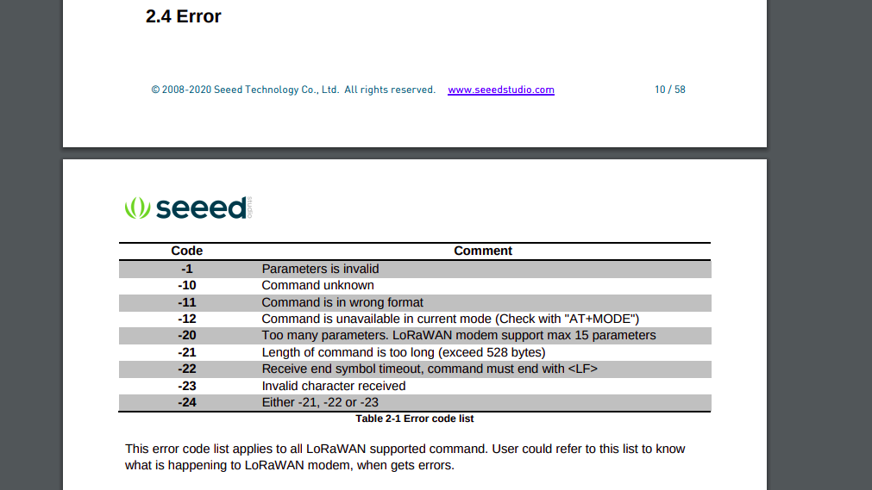

PIN CONNECTION FROM LoRa E5 TO ARDUINO

Arduino lora

Gnd gnd

D3 rx

D2 tx

PIN CONNECTION FROM ULTRSONIC TO ARDUINO

Arduino ultrasonic

Gnd gnd

11 echo

10 Trig

5v vcc

ARDUINO CODE

#include<SoftwareSerial.h>

// declare eui and key variables here

SoftwareSerial loraserial(2,3);

// declare ultrasonic sensor pins

int trig = 10;

int echo = 11;

float distance;

long duration;

char buffer[5];

void setup() {

pinMode(trig, OUTPUT);

pinMode(echo, INPUT);

Serial.begin(9600);

// initialize the serial communications and set up id's and key's

loraserial.begin(9600);

Serial.println("Process initiated");

delay(500);

loraserial.println("AT+JOIN");

}

void loop(){

// set pin modes for ultrasonic sensor

digitalWrite(trig, LOW);

delayMicroseconds(2);

digitalWrite(trig, HIGH);

delayMicroseconds(2);

digitalWrite(trig, LOW);

// calculate distance and send to lora serial

duration = pulseIn(echo, HIGH);

delayMicroseconds(2);

distance = duration * (0.034/2);

String str1 = String(distance, 3);

if(distance < 5){

Serial.println(str1);

if(Serial.available()){

loraserial.println("AT+MSG=" +str1);

}

if(loraserial.available()){

Serial.println(loraserial.readString());

delay(50);

}

}

}